NAME: G. Yashmita REG NO: 192511032
(Jira)
EXPERIMENT 9:
Create a Scrum Project in Jira.
• Add a backlog with at least 5 items (e.g., &quot;Create user
registration page&quot;, &quot;Develop API for login&quot;).
• Prioritize the backlog and create a 1-week sprint.
• Move backlog items into the sprint and start the sprint.
• Finally show the Screenshot of the sprint board at the start and
end of the sprint.

Aim

The objective of this experiment is to create a Scrum Project using Jira Software, add backlog items, create and start a sprint, and simulate the Scrum workflow by moving tasks through different stages.

Software Requirements

Software: Jira Cloud (Web Application)
Web Browser: Google Chrome / Microsoft Edge
Internet Connection: Required

Theory

Jira Scrum is an Agile project management tool used to manage software development through sprints. A Scrum project consists of a product backlog, sprint planning, active sprints, and task tracking. It helps teams prioritize work, collaborate effectively, and monitor project progress.

Procedure

Step 1:

Open a web browser and sign in to Jira Cloud using your account.
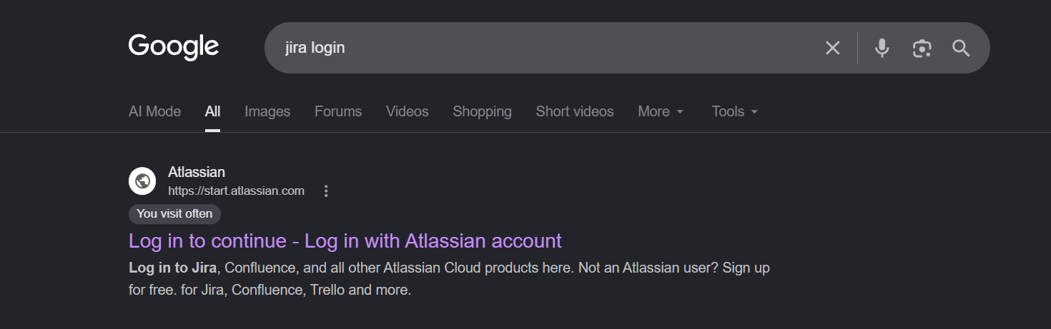
Figure 1. Opening Jira Cloud.

Step 2:
Open your Scrum project and click the Backlog tab.

Step 3:
Click Create and add at least five backlog items.
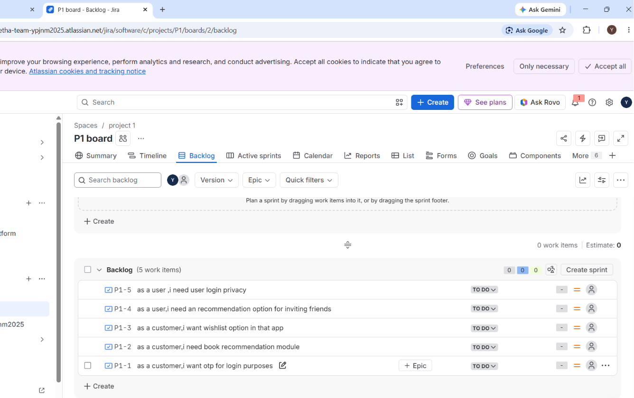
Figure 2. Creating Backlog Items.

Step 4:
Arrange the backlog items by priority using drag and drop.

Step 5:
Create a new 1-week Sprint (or use an existing sprint) and move all backlog items into the sprint.
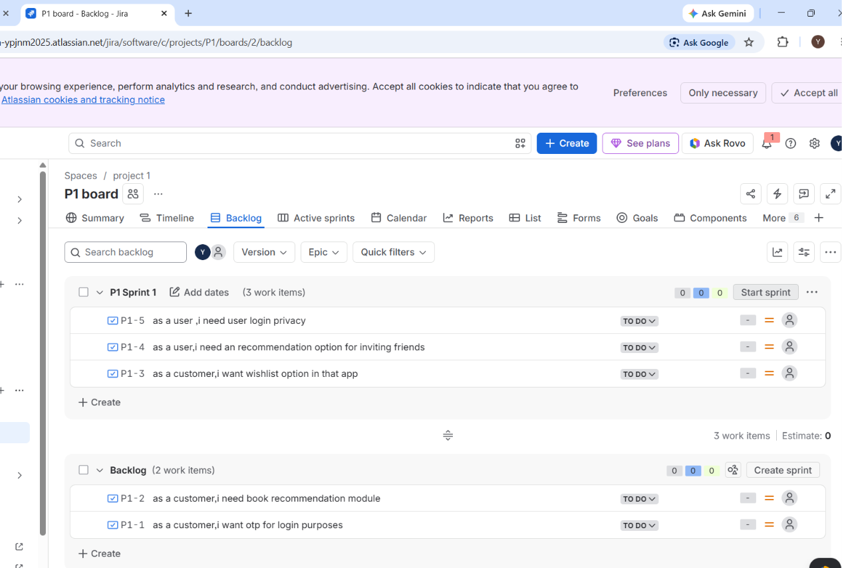Figure 3. Creating a Sprint.

Step 6:
Click Start Sprint to begin the sprint.

Step 7:
Open the Active Sprints tab to view the sprint board.
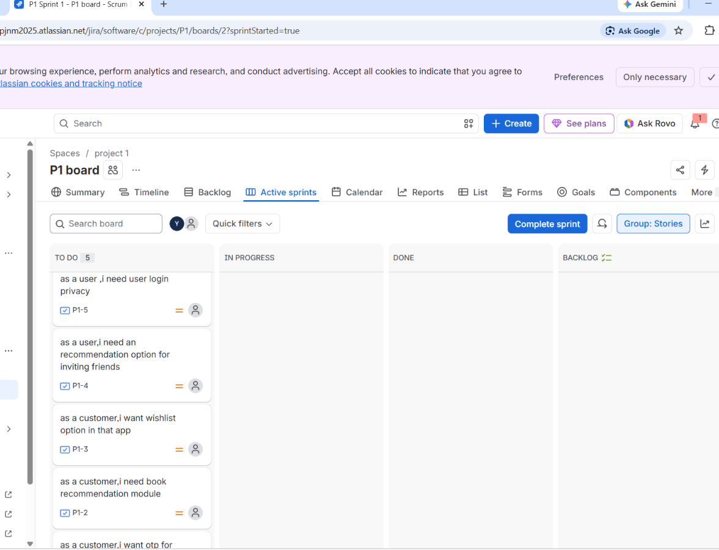
Figure 4. Active Sprint Board.

Step 8:
Move tasks across the workflow stages:
- To Do
- In Progress
- Done
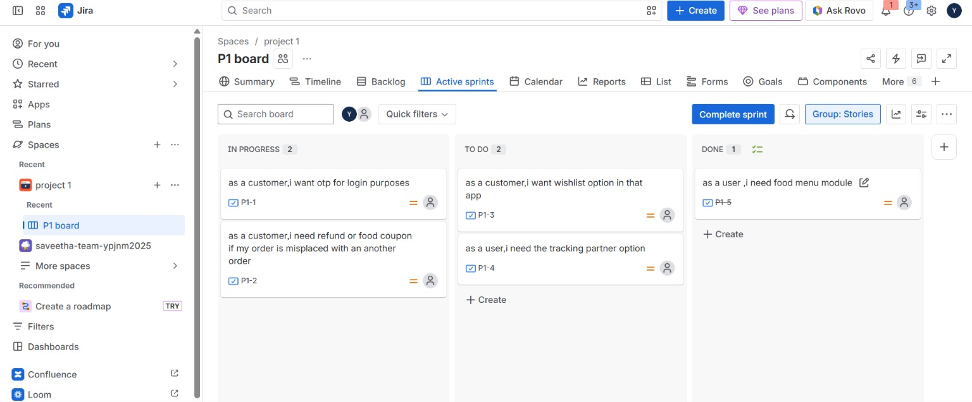
Figure 5. Completing the Sprint.
Result
The Scrum Project was successfully created using Jira Software. Backlog items were prioritized, added to a sprint, and moved through different workflow stages. The experiment demonstrated sprint planning, task tracking, and Scrum workflow management using Jira.

